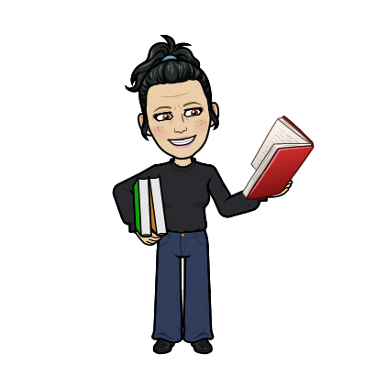Your Hawk Librarian!

Marion C. Brennan

Email me at [marion.brennan@fortbendisd.com](mailto:marion.brennan@fortbendisd.com)

Phone: (2810 634-3378

Reading, Sharks, Beaches are my favorite things!